**Experiment No: 8 Date:**

**CISCO PACKET TRACER BASICS**

**AIM:** 1) Create a basic network with six computers using appropriate wire through static IP address allocation and verify connectivity.

**THEORY:**

**Introduction:**

This experiment aims to construct a basic network comprising six computers, utilizing appropriate wiring and static IP address allocation. The primary objective is to verify and ensure seamless connectivity among the computers within the network.

**Problem Statement:**

The task involves setting up a network infrastructure with six computers and ensuring that they can communicate with each other effectively. This entails the configuration of static IP addresses for each computer and the physical establishment of connections using suitable wiring. The challenge lies in configuring the network components accurately to avoid connectivity issues and to ensure smooth data transmission.

**Advantages:**

1. **Controlled IP Address Allocation:** Utilizing static IP addresses allows for precise control over the network addressing scheme, eliminating the need for dynamic address assignment protocols like DHCP.
2. **Stability:** Static IP addresses contribute to network stability as they remain constant, reducing the chances of address conflicts or unexpected IP changes.
3. **Predictability:** With static IP addresses, network administrators can predict the network layout and easily troubleshoot connectivity issues by pinpointing the exact addresses of devices.
4. **Security:** By manually assigning IP addresses, administrators can implement stricter access controls and security measures tailored to specific devices.

**Disadvantages:**

1. **Administration Overhead:** Manually assigning static IP addresses to multiple devices can be time-consuming and labour-intensive, especially in larger networks.
2. **Potential for Address Conflicts:** If IP addresses are not managed meticulously, conflicts may arise, resulting in network disruptions or connectivity issues.
3. **Scalability Challenges:** In rapidly expanding networks, managing static IP addresses for numerous devices becomes increasingly complex and prone to errors.
4. **Limited Flexibility:** Static IP addresses may not be suitable for mobile devices or environments where network configurations frequently change.

**Real-World Application:**

This experiment mirrors real-world scenarios where network setup and configuration are crucial, such as:

1. **Small Office/Home Office (SOHO) Networks:** Setting up a basic network for a small office or home environment with a few computers sharing resources like printers and files.
2. **Educational Institutions:** Establishing networks in classrooms or computer labs to facilitate communication and resource sharing among students and faculty.
3. **Retail Businesses:** Implementing networks in retail stores for inventory management, POS systems, and back-office operations.
4. **Industrial Automation:** Configuring networks in industrial settings for machine-to-machine communication, process control, and data collection

**Example:**

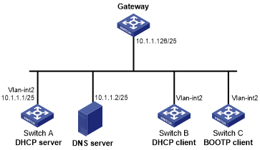

**Network Structure:**

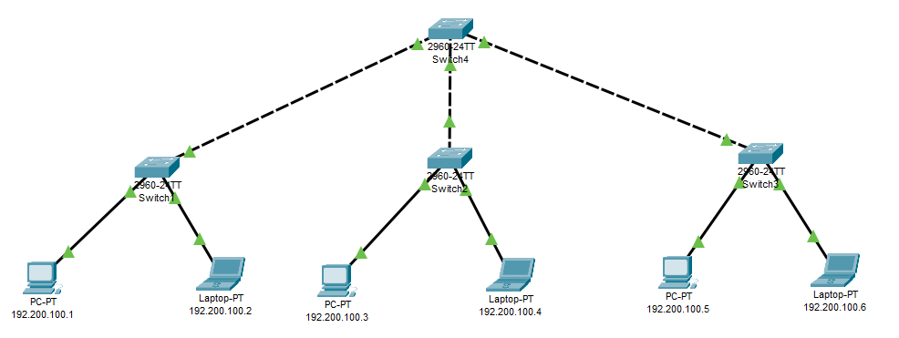

A Network with 6 computers using static IP Address allocation

**Verification of Connectivity:**

Sending a Simple PDU from PC 192.200.100.1 to Laptop 192.200.100.6

**Step 1:**

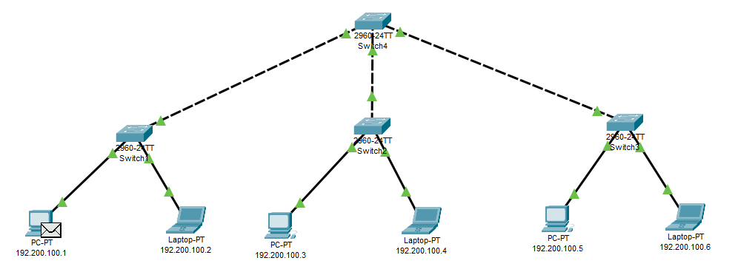

**Step 2:**

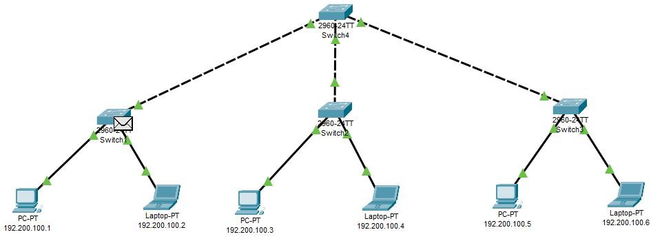

**Step 3:**

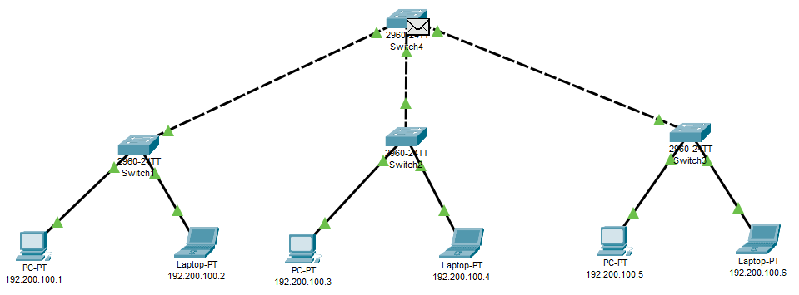

**Step 4:**

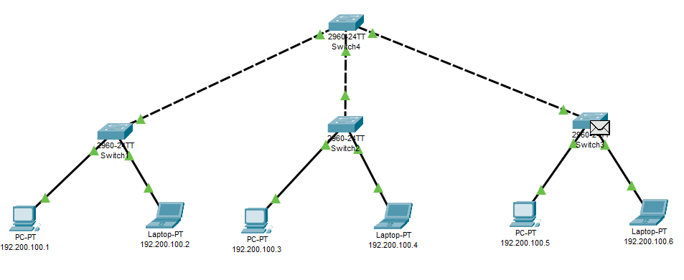

**Step 5:**

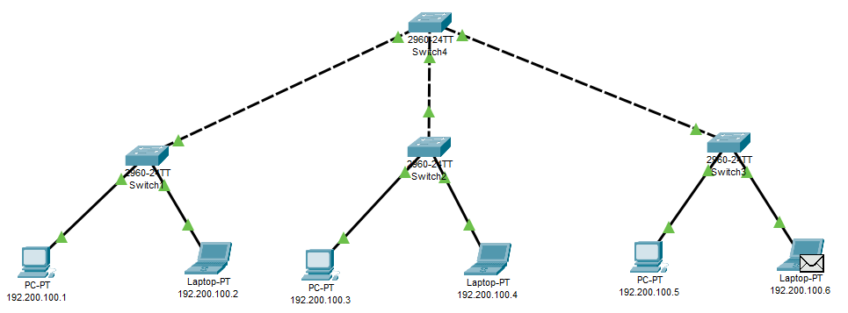

**CONCLUSION:**

A basic network with six computers using static IP address allocation was created and verified successfully.